**IEEE**

***Institute of Electrical and Electronic Engineers***

**Wednesday, October 23, 2013**

Prime 93 Restaurant

4315 Manchester Road., Akron, OH 44319

**Controlling, Electrically, The World’s Largest Systems**

**Dr. Allen G Morinec, P.E., FirstEnergy Corp.**

**IEEE Senior Member**

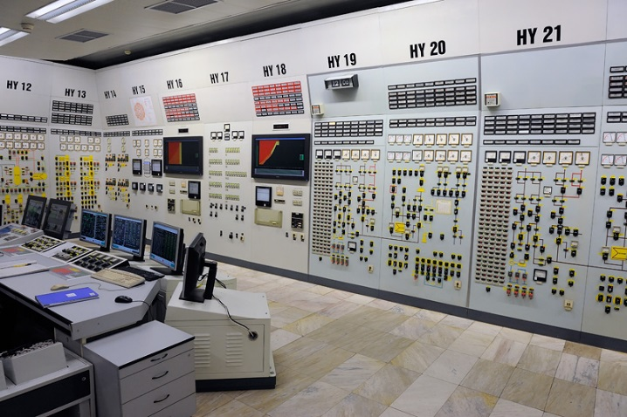

5:30 – Cash Bar

6:00 – Dinner

6:45 – Program

**Cost: $20 per person**

(Members and 1 guest)

**Students $10**

**Non-Members $25**

The Electric Power System is one of the world’s largest systems.  In 2011, The U.S. electric system had 1.05 Million Megawatts of Generation Capacity and 334 Million Customers. Controlling the electric system is a daunting task. The control systems for generation, transmission, and distribution systems will be presented and discussed.

**Choice of:**

**Lemon Herb Chicken**

**Grilled Chopped Sirloin**

**Lasagna**

Please contact Rick Buchanan at (330) 497-8250 or [RLBuchanan@att.net](mailto:RLBuchanan@att.net) for reservations no later than Monday, October 21. Please include your meal choice with your reservation.

**1 CPD Hour**